


Exploiting and Defense
Dobin Rutishauser 2016, 2017, 2018
Compass Security Schweiz AG | Tel +41 55 214 41 60
Werkstrasse 20 | Fax +41 55 214 41 61
Postfach 2038 | team@csnc.ch
CH-8645 Jona | www.csnc.ch

Intro
Compass Security Schweiz AG | Tel +41 55 214 41 60
Werkstrasse 20 | Fax +41 55 214 41 61
Postfach 2038 | team@csnc.ch
CH-8645 Jona | www.csnc.ch



About Me

Dobin Rutishauser
Working as Security Analyst @ Compass Security
Penetration Tests
Webapp Checks
Architecture Reviews
& lots more
Interested in Hacking Security since a young age (1998+)

© Compass Security Schweiz AG www.csnc.ch Slide 3

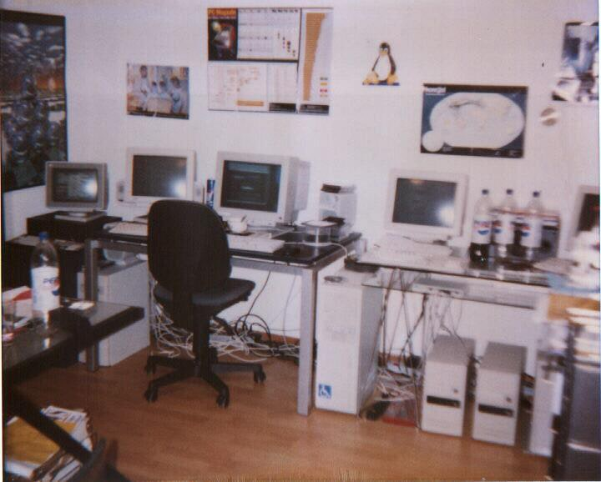
I got a bit overboard when I was little  © Compass Security Schweiz AG www.csnc.ch | Slide 4

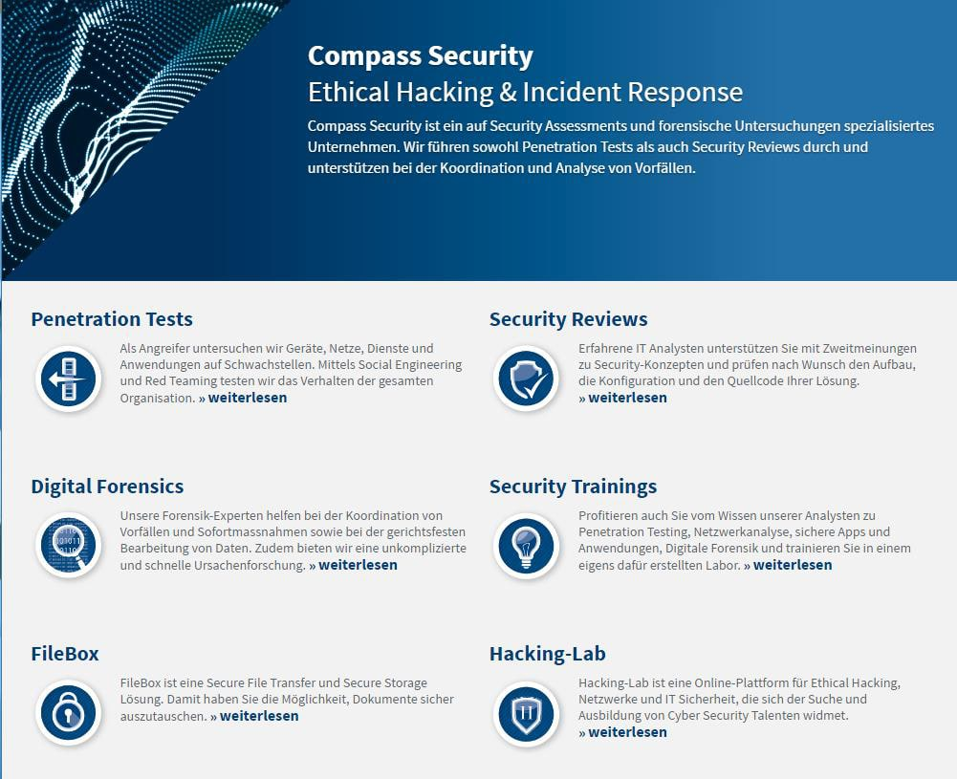
Compass  © Compass Security Schweiz AG www.csnc.ch | Slide 5

Compass is hiring (always)

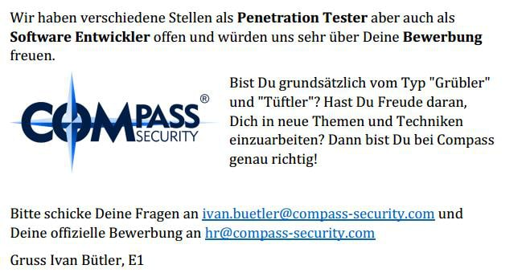
© Compass Security Schweiz AG www.csnc.ch Slide 6

Content
Compass Security Schweiz AG | Tel +41 55 214 41 60
Werkstrasse 20 | Fax +41 55 214 41 61
Postfach 2038 | team@csnc.ch
CH-8645 Jona | www.csnc.ch

Content

Exploit & Defense
We will write exploits to exploit buffer-overflows
We will analyze what defenses exist to make writing exploits harder
© Compass Security Schweiz AG www.csnc.ch Slide 8

Lecture
Compass Security Schweiz AG | Tel +41 55 214 41 60
Werkstrasse 20 | Fax +41 55 214 41 61
Postfach 2038 | team@csnc.ch
CH-8645 Jona | www.csnc.ch

Lecture  Website:  https://exploit.courses  Online exploit development website  Access to your own Linux via JavaScript terminal  Uses Hacking-Lab accounts  Solve challenges online  Write exploits  Debug stuff  https://www.hacking-lab.com  Half-online challenges website  Uses HLCD (Kali-based Linux Distribution) VPN-Based  Use this if you don’t like exploit.courses  © Compass Security Schweiz AG www.csnc.ch | Slide 10


Lecture
Siiiiii abr ähhhhh
EBP isch doch 32 bit?
© Compass Security Schweiz AG www.csnc.ch Slide 12

Motivation
Motivation for Exploiting & Defense
Compass Security Schweiz AG | Tel +41 55 214 41 60
Werkstrasse 20 | Fax +41 55 214 41 61
Postfach 2038 | team@csnc.ch
CH-8645 Jona | www.csnc.ch

Motivation

For the hacker:
Develop exploits
Debugging of C/C++ code
Disassembly & reversing of assembler code
Being 31337
For the Sysadmin
Judge security level of operating systems, and applications
Harden and protect servers, clients
For the CISO:
Assess CVSS scores
Assess (new) security mitigations
Better risk analysis
© Compass Security Schweiz AG www.csnc.ch Slide 14

Motivation

For everyone:
How do functions work?
How does the memory allocator work?
What’s the difference between userspace and kernelspace?
How does computer work?!
© Compass Security Schweiz AG www.csnc.ch Slide 15

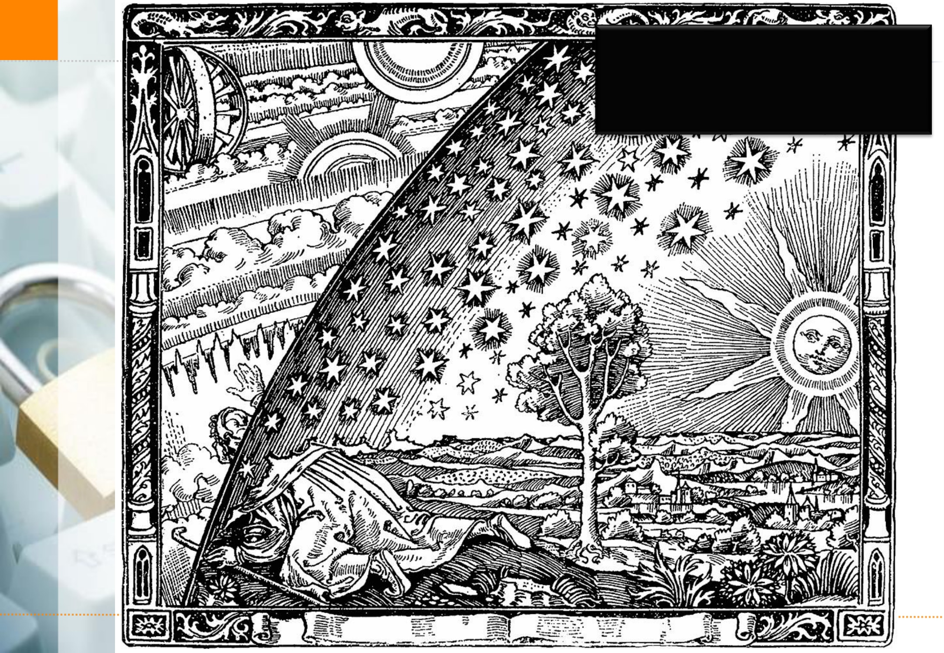
Content | Looking behind the curtain
© Compass Security Schweiz AG www.csnc.ch Slide 16

Motivation

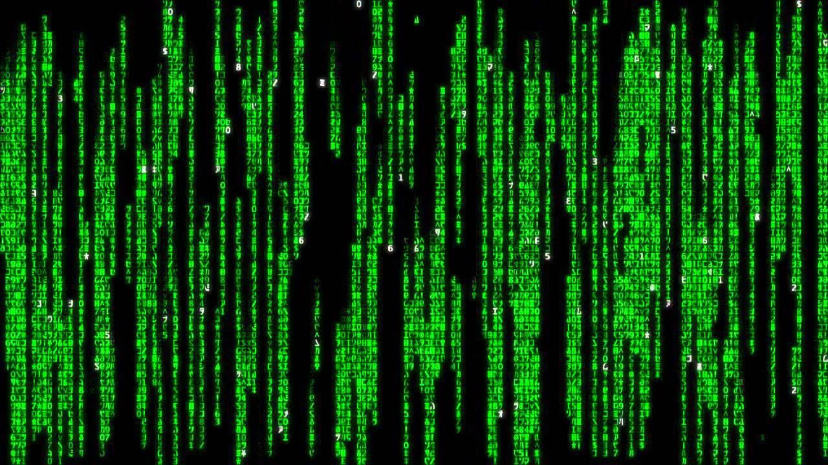
© Compass Security Schweiz AG www.csnc.ch Slide 17

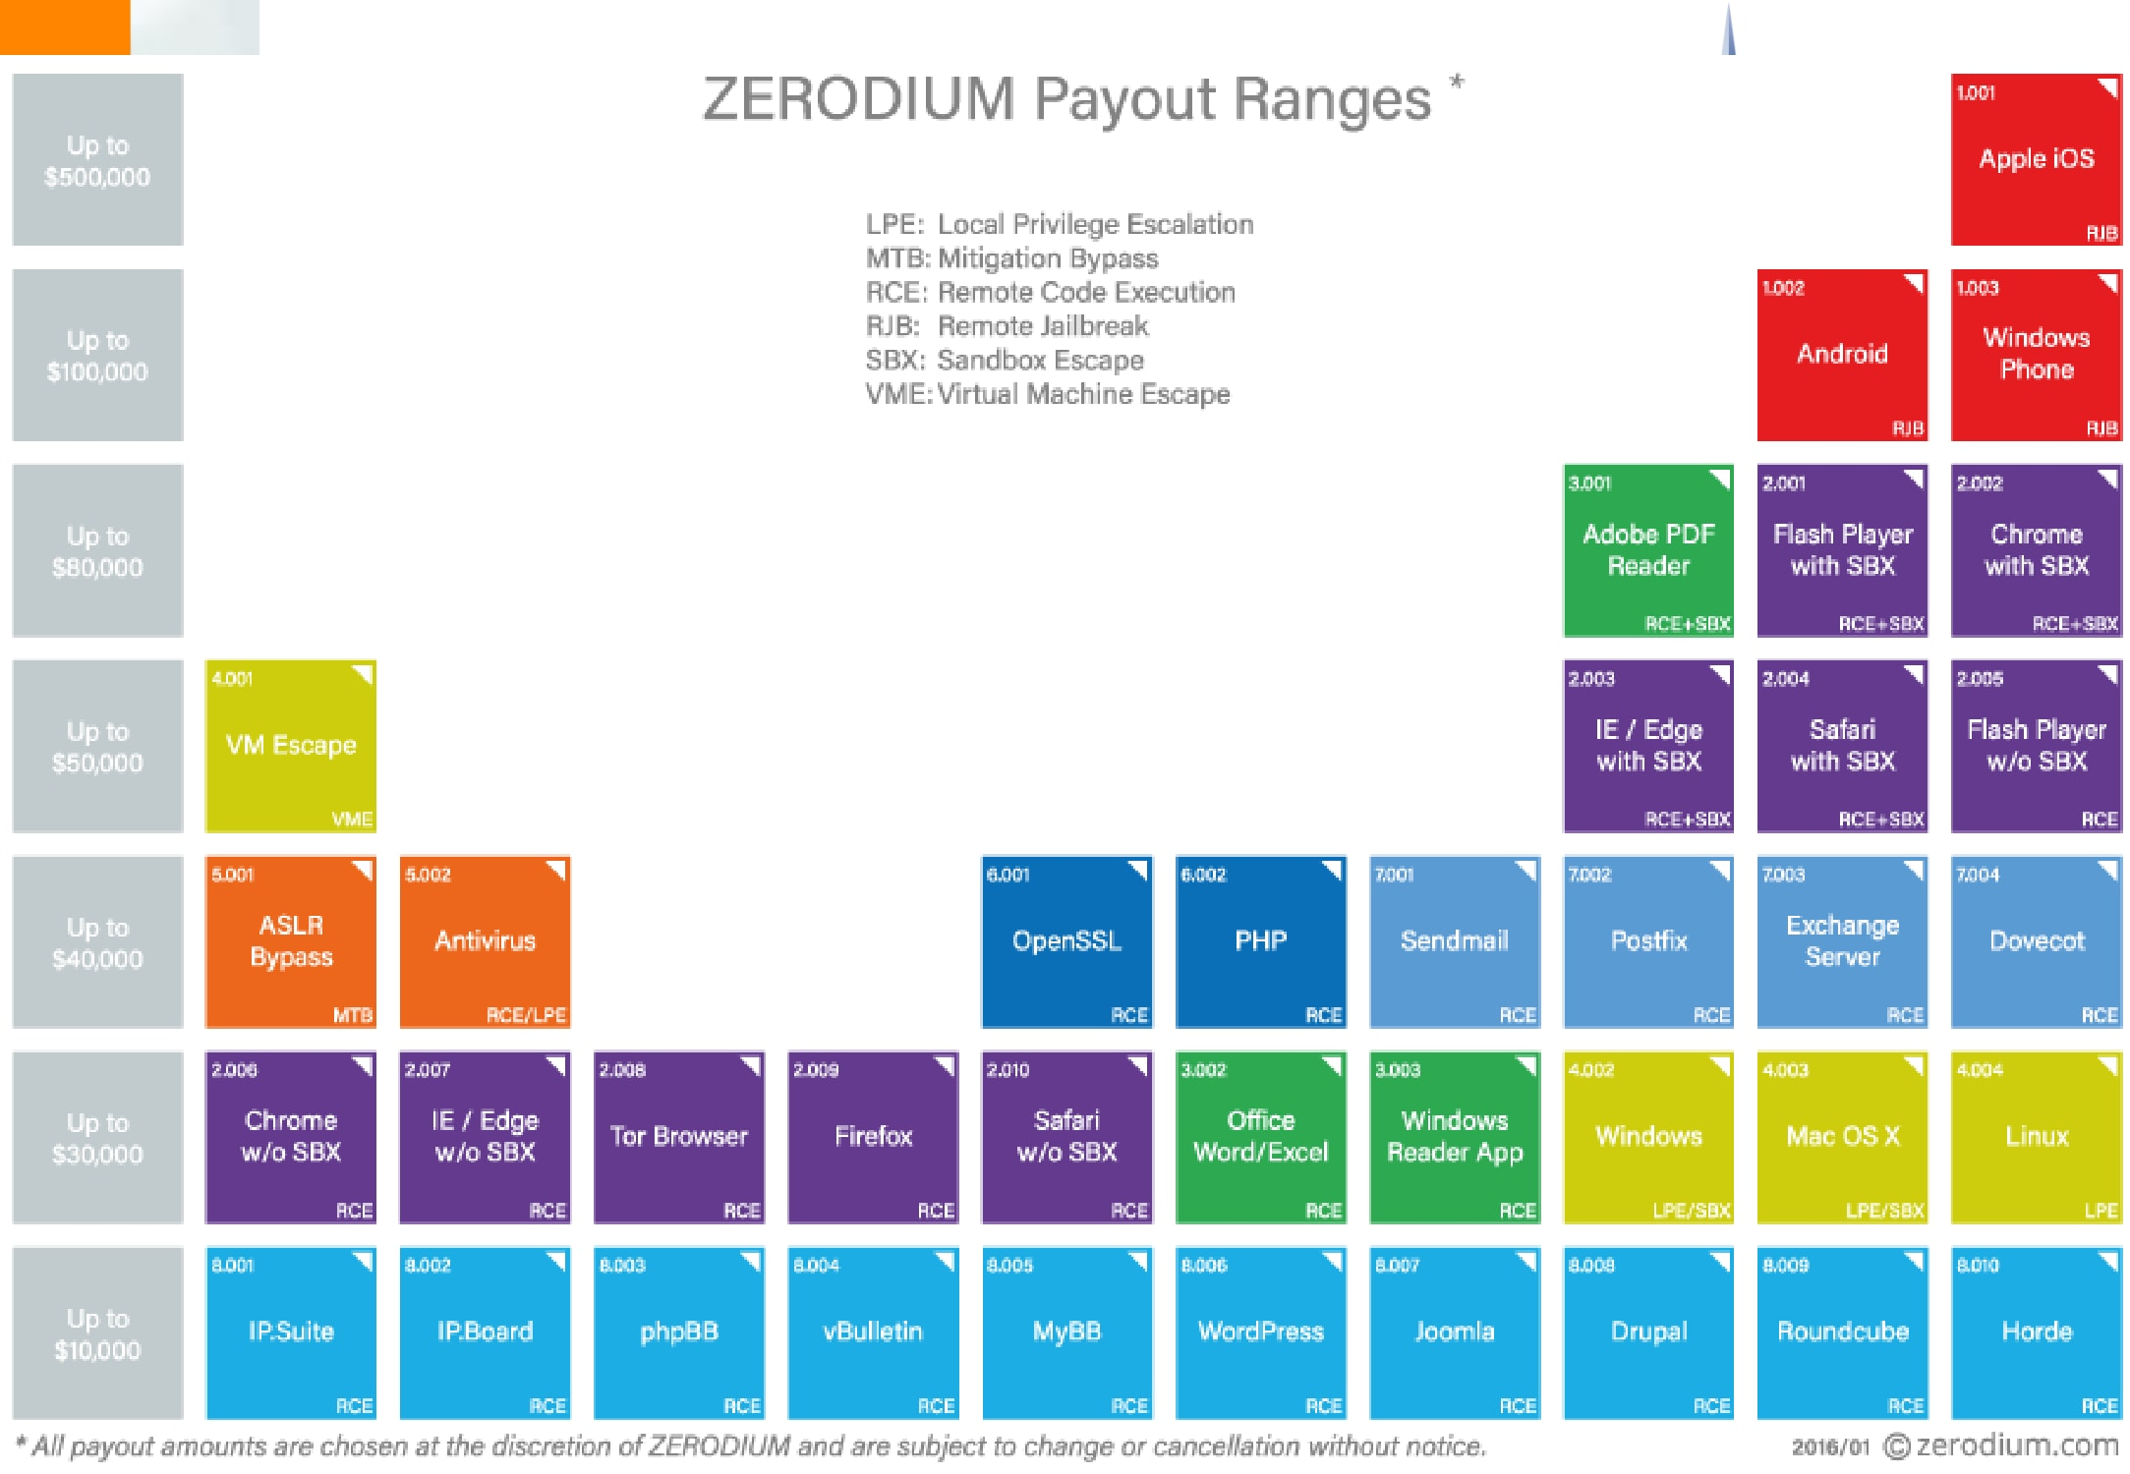
Motivation
© Compass Security Schweiz AG www.csnc.ch Slide 18

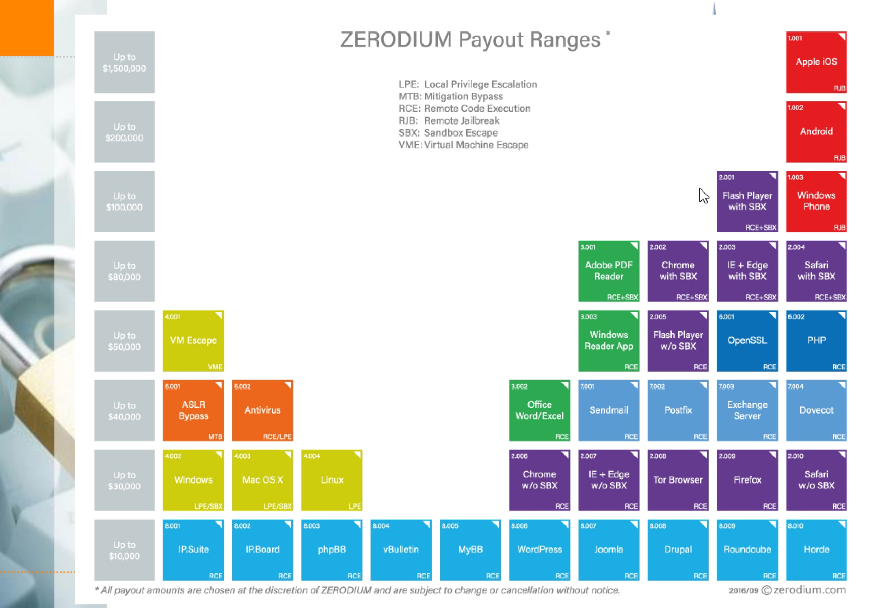
Motivation
© Compass Security Schweiz AG www.csnc.ch Slide 19

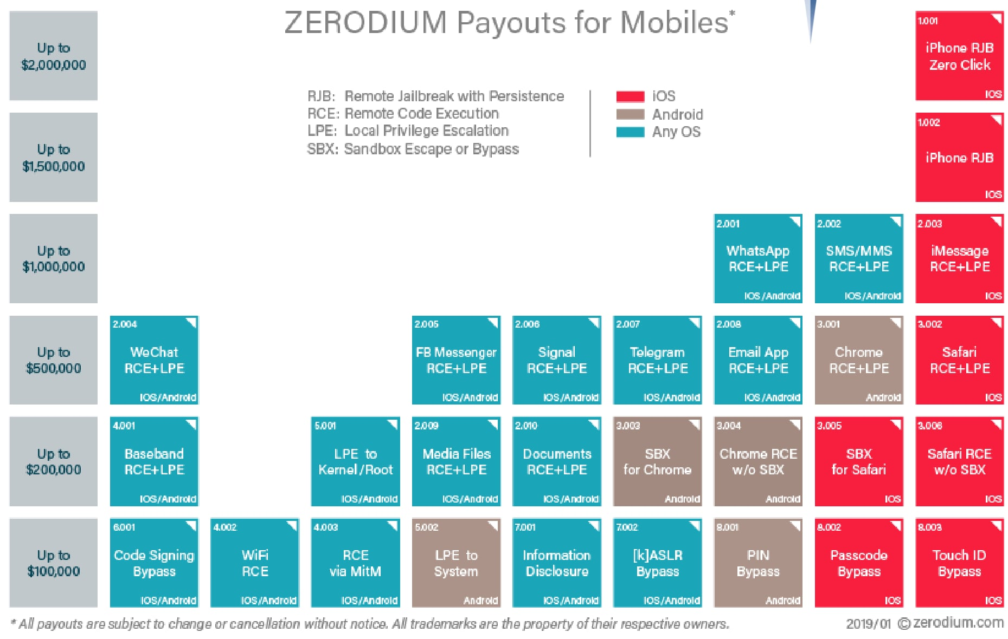
© Compass Security Schweiz AG www.csnc.ch Slide 20

Content of the next 8 Friday afternoons
Compass Security Schweiz AG | Tel +41 55 214 41 60
Werkstrasse 20 | Fax +41 55 214 41 61
Postfach 2038 | team@csnc.ch
CH-8645 Jona | www.csnc.ch

Content

You want to learn:
What memory corruptions are What buffer overflows are What exploits are
How exploits are being created To exploit a local application
To exploit a remote application
Learn about anti-exploiting technologies
To circumvent all common anti-exploiting technologies for Linux
See how Windows does it
Use Use-After-Free
Hack browsers
Hack facebook “for a friend”

© Compass Security Schweiz AG www.csnc.ch Slide 22

Content  You will actually learn:  Intel x86  Architecture  CPU  Registers  Linux  Userspace memory layout, stacks, heap  Syscalls  Sockets  Networking  Programming Languages  Assembler  C  Python  Bash  © Compass Security Schweiz AG www.csnc.ch | Slide 23

Plan
Compass Security Schweiz AG | Tel +41 55 214 41 60
Werkstrasse 20 | Fax +41 55 214 41 61
Postfach 2038 | team@csnc.ch
CH-8645 Jona | www.csnc.ch

Plan  29.03.2019  Theory:  0x01 Intro (this)  0x02 Intro Technical 0x10 Intel Architecture 0x11 Memory Layout  Challenges:  0: Introduction to memory layout - basic  1: Introduction to memory layout - advanced  © Compass Security Schweiz AG www.csnc.ch | Slide 25

Plan  05.04.2019  Theory:  0x12 C Array and Data Structures  0x30 Assembler Intro  0x31 Shellcode  0x32 Function Call Convention  0x33 Debugging  Challenges:  2: C buffer analysis - simple  3: Introduction to shellcode development  7: Function Call Convention in x86 (32bit)  8: C buffer analysis - with debugging  9: Simple Buffer overflow - variable overwrite  © Compass Security Schweiz AG www.csnc.ch | Slide 26

Plan

12.04.2019
Theory:
0x41 Buffer Overflow 0x42 Exploit
0x44 Remote Exploit
Challenges:
11: Development of a buffer overflow exploit - 32 bit
12: Development of a buffer overflow exploit - 64 bit
13: Development of a remote buffer overflow exploit - 64 bit
© Compass Security Schweiz AG www.csnc.ch Slide 27

Plan

26.04.2019
Theory:
0x51 Exploit Mitigation
0x52 Defeat Exploit Mitigation
0x53 Exploit Mitigation – PIE
0x54 Defeat Exploit Mitigation ROP
Challenges:
14: Stack canary brute force
15: Simple remote buffer overflow exploit - ASLR/DEP/64bit 16: Remote buffer overflow with ROP - DEP/64bit
17: Remote buffer overflow with ROP - DEP/ASLR/64bit
© Compass Security Schweiz AG www.csnc.ch Slide 28

Plan  03.05.2019  Theory:  0x55: Defeat Exploit Mitigation – Heap Intro 0x56: Defeat Exploit Mitigation – Heap Attacks  Challenges:  31: Heap use-after-free analysis  © Compass Security Schweiz AG www.csnc.ch | Slide 29

Plan  10.05.2019  Theory:  0x60: Windows Exploiting  0x70: Secure Coding  0x71: Fuzzing  Challenges:  60: Linux Hardening  © Compass Security Schweiz AG www.csnc.ch | Slide 30

Plan  17.05.2017  Theory:  0x72: Linux Hardening 0x73: Kernel Exploitation 0x74: Hardware Hacking  © Compass Security Schweiz AG www.csnc.ch | Slide 31

Plan  24.05.2017  Theory:  Puffer  Case Studies  Questions  © Compass Security Schweiz AG www.csnc.ch | Slide 32

Content

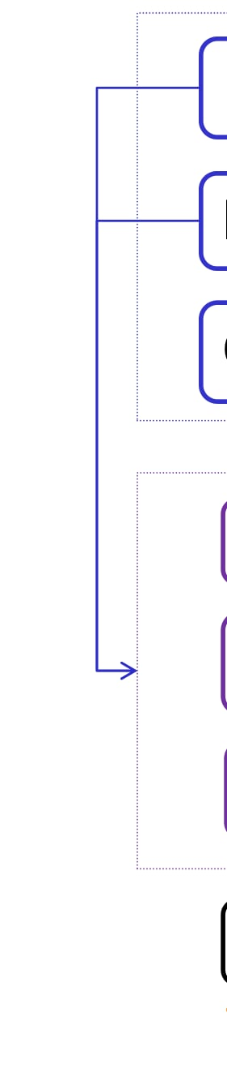
Intel Architecture
Memory Layout
C Arrays

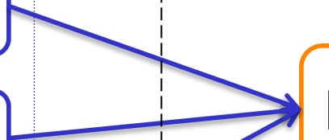
Buffer Overflow
BoF Exploit
Remote Exploit
Exploit Mitigations
Defeat Exploit Mitigations
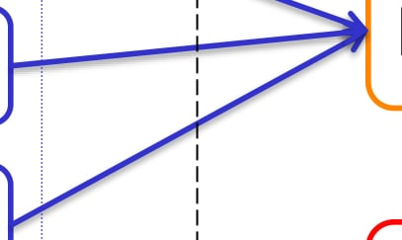
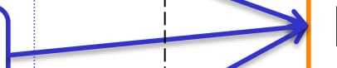
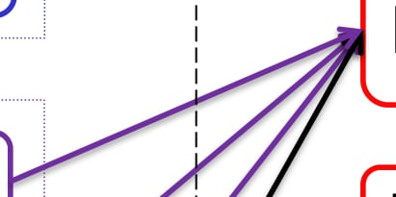
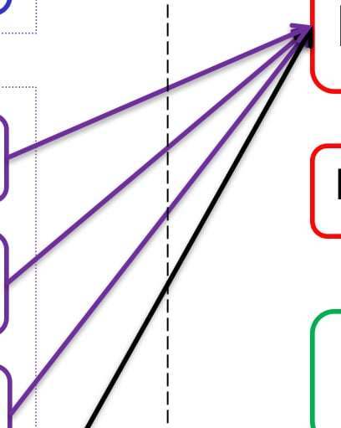
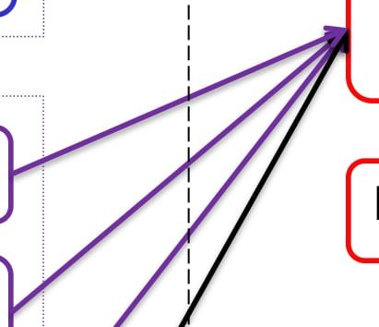
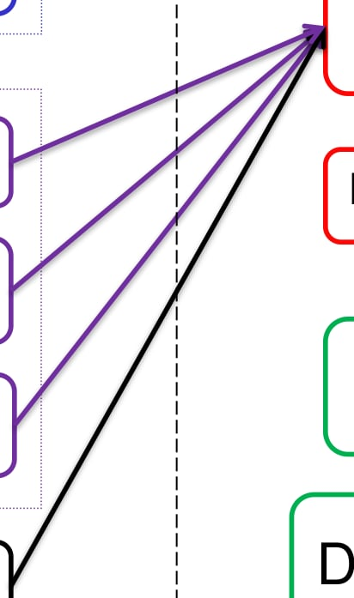
Assembler
Shellcode
Function Calls

Debugging
© Compass Security Schweiz AG www.csnc.ch Slide 33

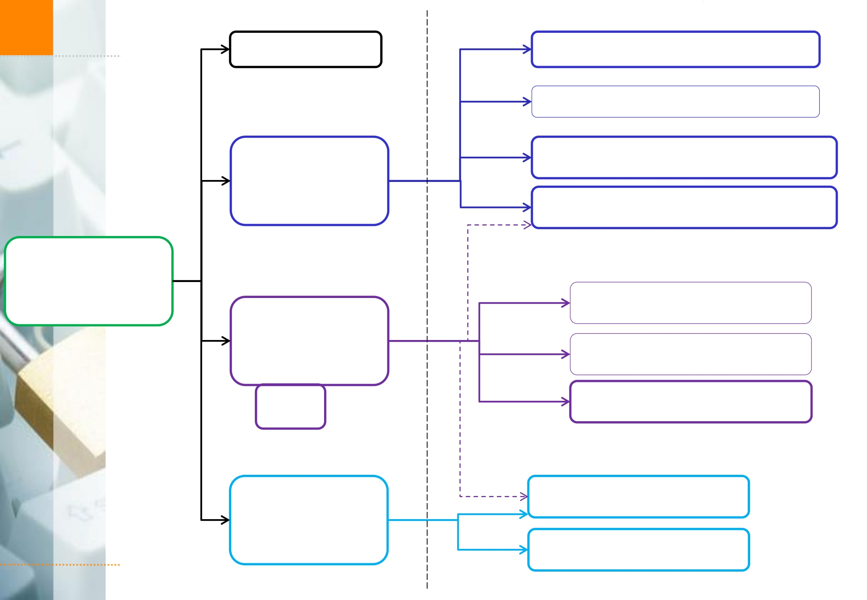
Exploit Mitigations | ASCII Armor  Stack  Canary  ASLR  PIE  DEP | Arbitrary Write  Overflow Local Vars  Heap Overflows  Brute Force  Partial RIP Overwrite  NOP Slide  Info Disclosure  Ret 2 PLT  ROP
© Compass Security Schweiz AG www.csnc.ch Slide 34

And:

Windows Exploiting

Secure Coding

Fuzzing

Linux Hardening

Browser Security

Case Studies

Kernel Exploits
© Compass Security Schweiz AG www.csnc.ch Slide 35

Exam Oral

What is (mainly) relevant for the oral exam?
How does memory corruption work?
How does an exploit work?
What exploit mitigations exist?
How can these exploit mitigations be circumvented?
More theoretical, not so much the nitty gritty details
Typical question:
Explain me how a buffer overflow exploit works
Now we introduce ASLR. What do you need to change?
© Compass Security Schweiz AG www.csnc.ch Slide 36

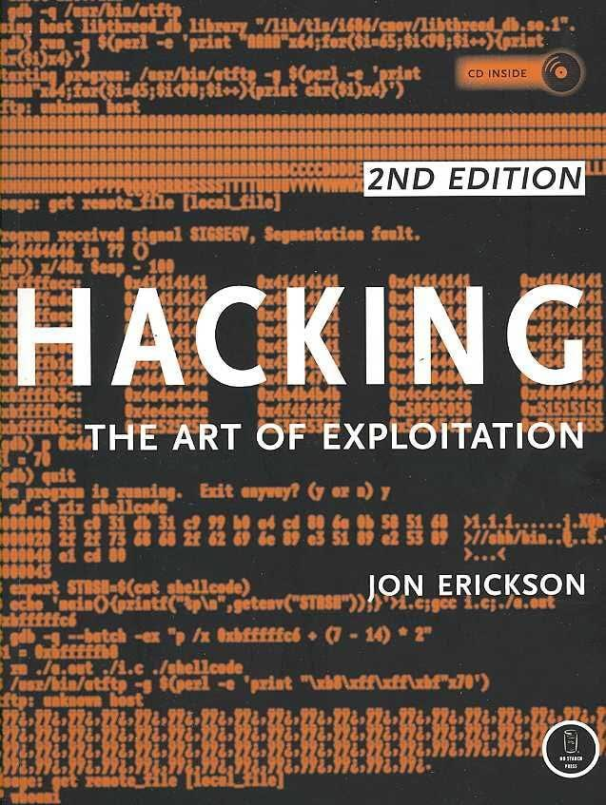
Books  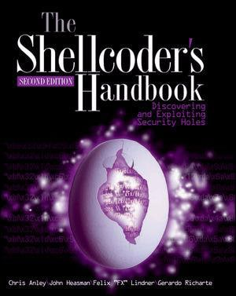  © Compass Security Schweiz AG www.csnc.ch | Slide 37

Legal Issue
Compass Security Schweiz AG | Tel +41 55 214 41 60
Werkstrasse 20 | Fax +41 55 214 41 61
Postfach 2038 | team@csnc.ch
CH-8645 Jona | www.csnc.ch

Legal CH

Don’t hack other people’s systems
«Damit der Tatbestand des strafbaren Hackens erfüllt ist, müssen folgende Voraussetzungen kumulativ erfüllt sein:
Eindringen in das Datenverarbeitungssystem;
fremdes Datenverarbeitungssystem;
Eindringen auf dem Weg der von Datenübertragungseinrichtungen;
besondere Sicherung gegen Zugriff.
https://www.lexwiki.ch/hacken/
© Compass Security Schweiz AG www.csnc.ch Slide 39

Legal International

Wassenaar

Arms Control Treaty
Anti-proliferation of Nukes and stuff
Includes now (?): Intrusion malware Intrusion exploits IP surveillance
-> Exploits are now weapons…
Not allowed to transport over the border
Exception: If they are open source
(stop selling 0-days to Chinese gov!)
http://blog.erratasec.com/2015/05/some-notes-about-wassenaar.html
© Compass Security Schweiz AG www.csnc.ch Slide 40

